PROGRAM 7: Develop a simple application with one EditText so that the user can write some text in it. Create a button called “Convert Text to Speech” that converts the user input text into voice.

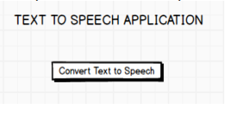

FILENAME:activity_main.xml

*<?*xml version="1.0" encoding="utf-8"*?>*<androidx.constraintlayout.widget.ConstraintLayout xmlns:android="http://schemas.android.com/apk/res/android"  
 xmlns:app="http://schemas.android.com/apk/res-auto"  
 xmlns:tools="http://schemas.android.com/tools"  
 android:layout_width="match_parent"  
 android:layout_height="match_parent"  
 tools:context=".MainActivity">  
  
 <TextView  
 android:id="@+id/textView"  
 android:layout_width="wrap_content"  
 android:layout_height="wrap_content"  
 android:text="TEXT TO SPEECH APPLICATION"  
 android:textColor="#FF5722"  
 android:textSize="24sp"  
 android:textStyle="bold"  
 app:layout_constraintBottom_toBottomOf="parent"  
 app:layout_constraintEnd_toEndOf="parent"  
 app:layout_constraintHorizontal_bias="0.506"  
 app:layout_constraintLeft_toLeftOf="parent"  
 app:layout_constraintRight_toRightOf="parent"  
 app:layout_constraintStart_toStartOf="parent"  
 app:layout_constraintTop_toTopOf="parent"  
 app:layout_constraintVertical_bias="0.169" />  
  
 <EditText  
 android:id="@+id/edt_txt"  
 android:layout_width="280dp"  
 android:layout_height="52dp"  
 android:ems="10"  
 android:inputType="textPersonName"  
 app:layout_constraintBottom_toBottomOf="parent"  
 app:layout_constraintEnd_toEndOf="parent"  
 app:layout_constraintStart_toStartOf="parent"  
 app:layout_constraintTop_toTopOf="parent"  
 app:layout_constraintVertical_bias="0.275" />  
  
 <Button  
 android:id="@+id/btn_speech"  
 android:layout_width="146dp"  
 android:layout_height="73dp"  
 android:background="#9C27B0"  
 android:text="SPEECH"  
 android:textColor="#FFFFFF"  
 android:textSize="20sp"  
 android:textStyle="bold"  
 app:layout_constraintBottom_toBottomOf="parent"  
 app:layout_constraintEnd_toEndOf="parent"  
 app:layout_constraintStart_toStartOf="parent"  
 app:layout_constraintTop_toTopOf="parent"  
 app:layout_constraintVertical_bias="0.451" />  
  
</androidx.constraintlayout.widget.ConstraintLayout>

FILENAME:ActivityMain.java

package com.example.texttospeech;  
  
import androidx.appcompat.app.AppCompatActivity;  
  
import android.os.Bundle;  
import android.speech.tts.TextToSpeech;  
import android.view.View;  
import android.widget.Button;  
import android.widget.EditText;  
import android.widget.Toast;  
  
import java.util.Locale;  
  
public class MainActivity extends AppCompatActivity implements View.OnClickListener, TextToSpeech.OnInitListener {  
 Button btnspeak;  
 EditText txtspeak;  
 TextToSpeech textToSpeech;  
  
  
 @Override  
 protected void onCreate(Bundle savedInstanceState) {  
 super.onCreate(savedInstanceState);  
 setContentView(R.layout.*activity_main*);  
 txtspeak=(EditText) findViewById(R.id.*edt_txt*);  
 btnspeak=(Button) findViewById(R.id.*btn_speech*);  
 btnspeak.setOnClickListener(this);  
 textToSpeech=new TextToSpeech(getBaseContext(),this);  
 textToSpeech.setLanguage(Locale.*ENGLISH*);  
 }  
  
 @Override  
 public void onClick(View view) {  
 String text=txtspeak.getText().toString();  
 textToSpeech.speak(text,TextToSpeech.*QUEUE_FLUSH*,null);  
  
 }  
  
 @Override  
 public void onInit(int status) {  
 if(status!=TextToSpeech.*ERROR*)  
 {  
 Toast.*makeText*(getBaseContext(),"success",Toast.*LENGTH_LONG*).show();  
 }  
  
 }  
}

output:

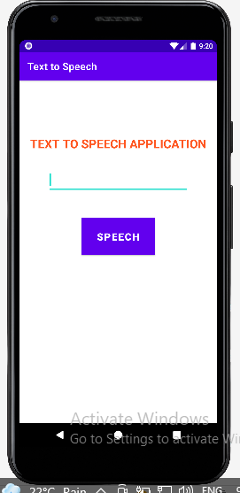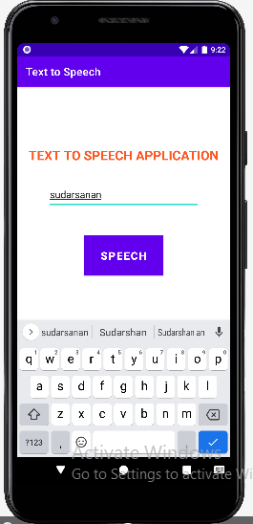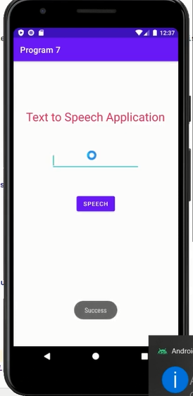

**Program 8:Create an activity like a phone dialer with CALL and SAVE buttons. On pressing the CALL button, it must call the phone number and on pressing the SAVE button it must save the number to the phone contacts.**

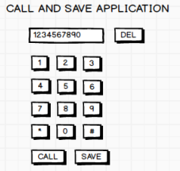

**Filename: activity_main.xml**

*<?*xml version="1.0" encoding="utf-8"*?>*<androidx.constraintlayout.widget.ConstraintLayout xmlns:android="http://schemas.android.com/apk/res/android"  
 xmlns:app="http://schemas.android.com/apk/res-auto"  
 xmlns:tools="http://schemas.android.com/tools"  
 android:layout_width="match_parent"  
 android:layout_height="match_parent"  
 tools:context=".MainActivity">  
  
 <Button  
 android:id="@+id/btncall"  
 android:layout_width="wrap_content"  
 android:layout_height="wrap_content"  
 android:background="#F44336"  
 android:text="CALL"  
 android:textColor="#F4EFEF"  
 android:textSize="20sp"  
 android:textStyle="bold"  
 app:layout_constraintBottom_toBottomOf="parent"  
 app:layout_constraintEnd_toEndOf="parent"  
 app:layout_constraintHorizontal_bias="0.498"  
 app:layout_constraintStart_toStartOf="parent"  
 app:layout_constraintTop_toBottomOf="@+id/display"  
 app:layout_constraintVertical_bias="0.904" />  
  
 <Button  
 android:id="@+id/btnrem"  
 android:layout_width="wrap_content"  
 android:layout_height="wrap_content"  
 android:background="#F44336"  
 android:text="DEL"  
 android:textColor="#F6F0F0"  
 android:textSize="20sp"  
 android:textStyle="bold"  
 app:layout_constraintBottom_toBottomOf="parent"  
 app:layout_constraintEnd_toEndOf="parent"  
 app:layout_constraintHorizontal_bias="0.871"  
 app:layout_constraintStart_toStartOf="parent"  
 app:layout_constraintTop_toBottomOf="@+id/display"  
 app:layout_constraintVertical_bias="0.904" />  
  
 <Button  
 android:id="@+id/btnsave"  
 android:layout_width="wrap_content"  
 android:layout_height="wrap_content"  
 android:background="#F44336"  
 android:text="SAVE"  
 android:textColor="#F8F4F4"  
 android:textSize="20sp"  
 app:layout_constraintBottom_toBottomOf="parent"  
 app:layout_constraintEnd_toEndOf="parent"  
 app:layout_constraintHorizontal_bias="0.117"  
 app:layout_constraintStart_toStartOf="parent"  
 app:layout_constraintTop_toBottomOf="@+id/display"  
 app:layout_constraintVertical_bias="0.904" />  
  
 <Button  
 android:id="@+id/btn0"  
 android:layout_width="wrap_content"  
 android:layout_height="wrap_content"  
 android:background="#F44336"  
 android:text="0"  
 android:textColor="#F3F0F0"  
 android:textSize="20sp"  
 app:layout_constraintBottom_toBottomOf="parent"  
 app:layout_constraintEnd_toEndOf="parent"  
 app:layout_constraintHorizontal_bias="0.498"  
 app:layout_constraintStart_toStartOf="parent"  
 app:layout_constraintTop_toBottomOf="@+id/display"  
 app:layout_constraintVertical_bias="0.761" />  
  
 <Button  
 android:id="@+id/btnhash"  
 android:layout_width="wrap_content"  
 android:layout_height="wrap_content"  
 android:background="#F44336"  
 android:text="#"  
 android:textColor="#FBF7F7"  
 android:textSize="20sp"  
 app:layout_constraintBottom_toBottomOf="parent"  
 app:layout_constraintEnd_toEndOf="parent"  
 app:layout_constraintHorizontal_bias="0.87"  
 app:layout_constraintStart_toStartOf="parent"  
 app:layout_constraintTop_toBottomOf="@+id/display"  
 app:layout_constraintVertical_bias="0.761" />  
  
 <Button  
 android:id="@+id/btnstar"  
 android:layout_width="wrap_content"  
 android:layout_height="wrap_content"  
 android:background="#F44336"  
 android:text="*"  
 android:textColor="#F8F5F5"  
 android:textSize="20sp"  
 app:layout_constraintBottom_toBottomOf="parent"  
 app:layout_constraintEnd_toEndOf="parent"  
 app:layout_constraintHorizontal_bias="0.117"  
 app:layout_constraintStart_toStartOf="parent"  
 app:layout_constraintTop_toBottomOf="@+id/display"  
 app:layout_constraintVertical_bias="0.761" />  
  
 <Button  
 android:id="@+id/btn8"  
 android:layout_width="wrap_content"  
 android:layout_height="wrap_content"  
 android:background="#F44336"  
 android:text="8"  
 android:textColor="#FAFAFA"  
 android:textSize="20sp"  
 app:layout_constraintBottom_toBottomOf="parent"  
 app:layout_constraintEnd_toEndOf="parent"  
 app:layout_constraintHorizontal_bias="0.498"  
 app:layout_constraintStart_toStartOf="parent"  
 app:layout_constraintTop_toBottomOf="@+id/display"  
 app:layout_constraintVertical_bias="0.611" />  
  
 <Button  
 android:id="@+id/btn9"  
 android:layout_width="wrap_content"  
 android:layout_height="wrap_content"  
 android:background="#F44336"  
 android:text="9"  
 android:textColor="#FAF6F6"  
 android:textSize="20sp"  
 app:layout_constraintBottom_toBottomOf="parent"  
 app:layout_constraintEnd_toEndOf="parent"  
 app:layout_constraintHorizontal_bias="0.87"  
 app:layout_constraintStart_toStartOf="parent"  
 app:layout_constraintTop_toBottomOf="@+id/display"  
 app:layout_constraintVertical_bias="0.611" />  
  
 <Button  
 android:id="@+id/btn7"  
 android:layout_width="wrap_content"  
 android:layout_height="wrap_content"  
 android:background="#F44336"  
 android:text="7"  
 android:textColor="#FFFDFD"  
 android:textSize="20sp"  
 app:layout_constraintBottom_toBottomOf="parent"  
 app:layout_constraintEnd_toEndOf="parent"  
 app:layout_constraintHorizontal_bias="0.117"  
 app:layout_constraintStart_toStartOf="parent"  
 app:layout_constraintTop_toBottomOf="@+id/display"  
 app:layout_constraintVertical_bias="0.611" />  
  
 <Button  
 android:id="@+id/btn5"  
 android:layout_width="wrap_content"  
 android:layout_height="wrap_content"  
 android:background="#F44336"  
 android:text="5"  
 android:textColor="#FDFBFB"  
 android:textSize="20sp"  
 app:layout_constraintBottom_toBottomOf="parent"  
 app:layout_constraintEnd_toEndOf="parent"  
 app:layout_constraintHorizontal_bias="0.498"  
 app:layout_constraintStart_toStartOf="parent"  
 app:layout_constraintTop_toBottomOf="@+id/display"  
 app:layout_constraintVertical_bias="0.44" />  
  
 <Button  
 android:id="@+id/btn6"  
 android:layout_width="wrap_content"  
 android:layout_height="wrap_content"  
 android:background="#F44336"  
 android:text="6"  
 android:textColor="#FAF5F5"  
 android:textSize="20sp"  
 app:layout_constraintBottom_toBottomOf="parent"  
 app:layout_constraintEnd_toEndOf="parent"  
 app:layout_constraintHorizontal_bias="0.87"  
 app:layout_constraintStart_toStartOf="parent"  
 app:layout_constraintTop_toBottomOf="@+id/display"  
 app:layout_constraintVertical_bias="0.44" />  
  
 <Button  
 android:id="@+id/btn4"  
 android:layout_width="wrap_content"  
 android:layout_height="wrap_content"  
 android:background="#F44336"  
 android:text="4"  
 android:textColor="#FBFAFA"  
 android:textSize="20sp"  
 app:layout_constraintBottom_toBottomOf="parent"  
 app:layout_constraintEnd_toEndOf="parent"  
 app:layout_constraintHorizontal_bias="0.117"  
 app:layout_constraintStart_toStartOf="parent"  
 app:layout_constraintTop_toBottomOf="@+id/display"  
 app:layout_constraintVertical_bias="0.44" />  
  
 <EditText  
 android:id="@+id/display"  
 android:layout_width="280dp"  
 android:layout_height="71dp"  
 android:ems="10"  
 android:inputType="phone"  
 app:layout_constraintBottom_toBottomOf="parent"  
 app:layout_constraintEnd_toEndOf="parent"  
 app:layout_constraintHorizontal_bias="0.412"  
 app:layout_constraintStart_toStartOf="parent"  
 app:layout_constraintTop_toTopOf="parent"  
 app:layout_constraintVertical_bias="0.231"  
 tools:ignore="SpeakableTextPresentCheck" />  
  
 <Button  
 android:id="@+id/btn2"  
 android:layout_width="wrap_content"  
 android:layout_height="wrap_content"  
 android:background="#F44336"  
 android:text="2"  
 android:textColor="#F8F3F3"  
 android:textSize="20sp"  
 app:layout_constraintBottom_toBottomOf="parent"  
 app:layout_constraintEnd_toEndOf="parent"  
 app:layout_constraintHorizontal_bias="0.498"  
 app:layout_constraintStart_toStartOf="parent"  
 app:layout_constraintTop_toBottomOf="@+id/display"  
 app:layout_constraintVertical_bias="0.27" />  
  
 <Button  
 android:id="@+id/btn1"  
 android:layout_width="wrap_content"  
 android:layout_height="wrap_content"  
 android:background="#F44336"  
 android:text="1"  
 android:textColor="#F8F3F3"  
 android:textSize="20sp"  
 android:textStyle="bold"  
 app:layout_constraintBottom_toBottomOf="parent"  
 app:layout_constraintEnd_toEndOf="parent"  
 app:layout_constraintHorizontal_bias="0.117"  
 app:layout_constraintStart_toStartOf="parent"  
 app:layout_constraintTop_toBottomOf="@+id/display"  
 app:layout_constraintVertical_bias="0.27" />  
  
 <Button  
 android:id="@+id/btn3"  
 android:layout_width="92dp"  
 android:layout_height="42dp"  
 android:background="#F44336"  
 android:text="3"  
 android:textColor="#FAF6F6"  
 android:textSize="20sp"  
 app:layout_constraintBottom_toBottomOf="parent"  
 app:layout_constraintEnd_toEndOf="parent"  
 app:layout_constraintHorizontal_bias="0.87"  
 app:layout_constraintStart_toStartOf="parent"  
 app:layout_constraintTop_toBottomOf="@+id/display"  
 app:layout_constraintVertical_bias="0.27"  
 tools:ignore="TouchTargetSizeCheck" />  
  
 <TextView  
 android:id="@+id/textView"  
 android:layout_width="385dp"  
 android:layout_height="47dp"  
 android:layout_marginTop="64dp"  
 android:text="CALL AND SAVE APPLICATION"  
 android:textAlignment="center"  
 android:textColor="#9C27B0"  
 android:textSize="24sp"  
 android:textStyle="bold"  
 app:layout_constraintEnd_toEndOf="parent"  
 app:layout_constraintStart_toStartOf="parent"  
 app:layout_constraintTop_toTopOf="parent" />  
</androidx.constraintlayout.widget.ConstraintLayout>

**Filename:MainActivity.java**

package com.example.program8;  
  
import androidx.appcompat.app.AppCompatActivity;  
  
import android.content.Intent;  
import android.net.Uri;  
import android.os.Bundle;  
import android.provider.ContactsContract;  
import android.view.View;  
import android.widget.Button;  
import android.widget.EditText;  
  
public class MainActivity extends AppCompatActivity implements View.OnClickListener {  
 EditText Display;  
 Button btn_1,btn_2,btn_3,btn_4,btn_5,btn_6,btn_7,btn_8,btn_9,btn_0;  
 Button btn_star,btn_hash,btn_del,btn_call,btn_save;  
  
 @Override  
 protected void onCreate(Bundle savedInstanceState) {  
 super.onCreate(savedInstanceState);  
 setContentView(R.layout.*activity_main*);  
 btn_0=(Button)findViewById(R.id.*btn0*);  
 btn_0.setOnClickListener(this);  
 btn_1=(Button)findViewById(R.id.*btn1*);  
 btn_1.setOnClickListener(this);  
 btn_2=(Button)findViewById(R.id.*btn2*);  
 btn_2.setOnClickListener(this);  
 btn_3=(Button)findViewById(R.id.*btn3*);  
 btn_3.setOnClickListener(this);  
 btn_4=(Button)findViewById(R.id.*btn4*);  
 btn_4.setOnClickListener(this);  
 btn_5=(Button)findViewById(R.id.*btn5*);  
 btn_5.setOnClickListener(this);  
 btn_6=(Button)findViewById(R.id.*btn6*);  
 btn_6.setOnClickListener(this);  
 btn_7=(Button)findViewById(R.id.*btn7*);  
 btn_7.setOnClickListener(this);  
 btn_8=(Button)findViewById(R.id.*btn8*);  
 btn_8.setOnClickListener(this);  
 btn_9=(Button)findViewById(R.id.*btn9*);  
 btn_9.setOnClickListener(this);  
  
 btn_call=findViewById(R.id.*btncall*);  
 btn_call.setOnClickListener(this);  
 btn_save=findViewById(R.id.*btnsave*);  
 btn_save.setOnClickListener(this);  
 btn_star=findViewById(R.id.*btnstar*);  
 btn_star.setOnClickListener(this);  
 btn_del=findViewById(R.id.*btnrem*);  
 btn_del.setOnClickListener(this);  
 btn_hash=findViewById(R.id.*btnhash*);  
 btn_hash.setOnClickListener(this);  
  
 Display=(EditText) findViewById(R.id.*display*);  
 Display.setText("");  
  
  
 }  
  
 @Override  
 public void onClick(View view) {  
 if(view.equals(btn_1))  
 Display.append("1");  
 else if(view.equals(btn_2)) Display.append("2");  
 else if(view.equals(btn_3))Display.append("3");  
 else if(view.equals(btn_4))Display.append("4");  
 else if(view.equals(btn_5))Display.append("5");  
 else if(view.equals(btn_6)) Display.append("6");  
 else if(view.equals(btn_7))Display.append("7");  
 else if(view.equals(btn_8))Display.append("8");  
 else if(view.equals(btn_9))Display.append("9");  
 else if(view.equals(btn_0))Display.append("0");  
 else if(view.equals(btn_star)) Display.append("*");  
 else if(view.equals(btn_hash))Display.append("#");  
 else if(view.equals(btn_save))  
 {  
 Intent contactIntent= new Intent(ContactsContract.Intents.Insert.*ACTION*);  
 contactIntent.setType(ContactsContract.RawContacts.*CONTENT_TYPE*);  
 contactIntent.putExtra(ContactsContract.Intents.Insert.*NAME*,"Unknown");  
 contactIntent.putExtra(ContactsContract.Intents.Insert.*PHONE*,Display.getText().toString());  
 startActivity(contactIntent);  
 }  
 else if(view.equals(btn_del))  
 {  
 String data=Display.getText().toString();  
 if(data.length()>0)  
 Display.setText(data.substring(0,data.length()-1));  
 else  
 Display.setText("");  
 }  
 btn_call.setOnClickListener(new View.OnClickListener()  
 {  
 @Override  
 public void onClick(View v) {  
 String data = Display.getText().toString();Intent  
 intent=new Intent(Intent.*ACTION_DIAL*);  
 intent.setData(Uri.*parse*("tel:"+ data));  
 startActivity(intent);  
 }  
 }  
 );  
 }  
}

**OUTPUT:**

**phone dialer with CALL**

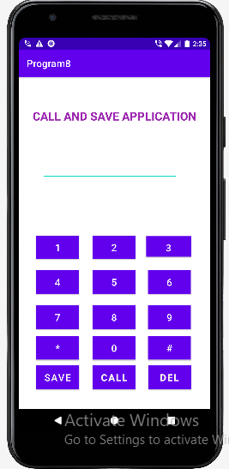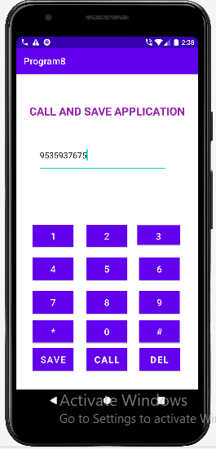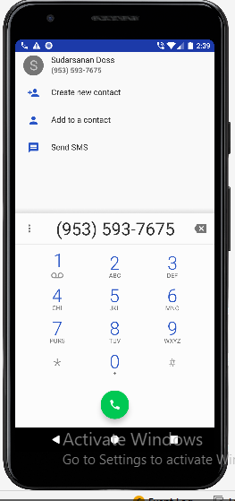

**phone dialer with SAVE**

